**Intel College Excellence Program   
Project Synopsis**

**“****Personal Cloud Server with Nextcloud”**

|  |  |  |  |
| --- | --- | --- | --- |
| **Team member’s detail** | | | |
| **S. No.** | **Participant Name** | **Mobile No.** | **Email ID** |
| 1 | Kshatri Syam Sahil Singh | 7207419008 | ***ksyamsahilsingh11@gmail.com*** |
| **Faculty(college) mentor detail** | | | |
| **S. No.** | **Mentor Name** | **Mobile No.** | **Email ID** |
| 1 | Dr. Shelej Khera | 9466731632 | ***shelej.22390@lpu.co.in*** |
| **College/University Name** | | | |
| ***Lovely Professional University*** | | | |

**BACKGROUND**

In the age of cloud computing, data accessibility, and personal privacy concerns, having control over one’s own data is becoming increasingly essential. Nextcloud offers a self-hosted, open-source cloud storage solution that enables users to securely store, sync, and share files across multiple devices. Traditional cloud storage services like Google Drive or Dropbox offer convenience but come at the cost of relinquishing control over personal data to third-party providers. Nextcloud addresses this by providing users with complete ownership and management of their data, ensuring that files remain private and secure.

Moreover, Nextcloud is highly customizable, allowing users to expand its functionality through a variety of plugins and integrations, such as calendar management, document editing, and even video conferencing. The ability to self-host means that Nextcloud can be deployed on local servers, providing greater speed and access control, while also being accessible remotely through services like Ngrok, which allows for temporary, secure exposure of local servers to the internet. By integrating tools like Ngrok and automating processes through crontab, users can seamlessly maintain access to their Nextcloud instances from anywhere, without needing complex network configurations.

As concerns about privacy, data sovereignty, and control over personal information grow, Nextcloud stands out as a powerful alternative to commercial cloud services, giving users the flexibility to manage their own data infrastructure, enhance their workflows, and ensure that sensitive information remains protected under their own security protocols. This project not only emphasizes the importance of personal data control but also highlights how tools like Ngrok and automation techniques can make managing such services more convenient and accessible for users in the modern digital landscape.

**PROBLEM IDENTIFICATION**

In today’s digital landscape, individuals and organizations increasingly struggle with efficiently managing their data and ensuring seamless access across multiple devices. The overwhelming amount of personal files—such as documents, photos, and videos—often leads to disorganization and difficulty in locating important information. Traditional cloud storage services can create additional barriers, including subscription costs, limited storage options, and lack of control over data privacy, making it hard for users to trust external providers with their sensitive information.

Furthermore, users often encounter issues related to bandwidth limitations and inconsistent internet connectivity when accessing cloud services remotely. These factors contribute to slow upload and download speeds, frequent timeouts, and ultimately hinder productivity. When dealing with larger files, such as high-resolution images or extensive video libraries, the challenges of data transfer become even more pronounced, leading to frustration and inefficiency.

Security and privacy concerns are paramount, particularly when users are required to trust third-party cloud providers with their personal and sensitive data. The potential for data breaches, unauthorized access, and inadequate encryption measures raises significant apprehension among users. Additionally, navigating complex sharing permissions and access controls can prove challenging for users who wish to collaborate securely with family or colleagues.

Customization is another significant challenge; many existing cloud solutions offer limited options for tailoring the storage experience to fit individual needs. Users often desire a more personalized approach to organizing and accessing their files, but traditional services do not provide the flexibility to create a tailored environment.

Backup and data recovery solutions are crucial yet frequently overlooked. Users often fail to establish effective strategies to safeguard their data, increasing the risk of permanent loss from hardware failures or accidental deletions. This situation is exacerbated by the need for continuous updates and maintenance of cloud server software, which can be daunting for those lacking technical expertise.

**PROPOSED SOLUTION**

**Efficient File Management and Collaboration**

Nextcloud provides an organized platform for managing files, documents, and collaborative projects efficiently. Users can upload, share, and access files from any device, promoting a seamless workflow. With built-in version control, Nextcloud enables users to track changes made to documents and revert to previous versions when necessary. The intuitive interface allows for easy navigation and file retrieval, enhancing productivity and ensuring that important documents are always at hand.

**Secure Remote Access and Synchronization**

Nextcloud ensures secure remote access to files and folders, enabling users to synchronize their data across multiple devices seamlessly. This feature mitigates concerns about data accessibility while traveling or working remotely. By using end-to-end encryption and secure sharing links, Nextcloud protects sensitive information from unauthorized access, fostering a trustworthy environment for collaboration. Users can also set expiration dates and download limits on shared links, ensuring additional control over their data.

**Customizable User Management and Permissions**

Nextcloud excels in user management by allowing administrators to create individualized accounts with customizable permissions. This feature enables organizations to define access levels for different users or groups, ensuring that sensitive files are only available to authorized personnel. The ability to monitor user activity and manage user permissions fosters a collaborative yet secure environment, catering to varying privacy requirements within teams or organizations.

**Integration and Extensibility**

Nextcloud is designed to integrate seamlessly with various third-party applications and services, enhancing its functionality. Users can add features like calendar management, task lists, and contact synchronization, tailoring the platform to meet specific needs. Additionally, the open-source nature of Nextcloud encourages community-driven development, enabling users to create or implement custom applications that expand the platform’s capabilities, ensuring it remains relevant and adaptable over time.

**Robust Data Backup and Recovery**

Nextcloud facilitates efficient data backup and recovery options, minimizing the risk of data loss. With automatic backup solutions and the option to configure regular snapshots, users can ensure their files are consistently safeguarded. In case of accidental deletion or corruption, the restore feature allows users to recover lost files quickly, providing peace of mind and maintaining business continuity.

**Setup Essentials**

**Hardware Requirements:**

1. Server Machine
2. Network Equipment
3. Backup Storage (Optional)

**Software Requirements:**

1. Operating System
2. Nextcloud Server Application
3. Ngrok Account

**DESCRIPTION**

**Personal Cloud Server with Nextcloud**

This project involves the deployment of a Nextcloud server on an Ubuntu-based system, allowing users to create a private cloud storage solution that is accessible from anywhere in the world. Nextcloud is an open-source software suite that enables file synchronization and sharing, providing a robust alternative to commercial cloud storage services. The server is configured to be publicly accessible using Ngrok, a tool that creates secure tunnels to localhost, allowing for external access to the Nextcloud instance without the need for complex network configurations like port forwarding.

**The below content will guide you to Install, Setup, Configure nextcloud,MariaDB, PHP, Ngrok which are required to accomplish Personal Cloud Server.**

**Table of Contents**

1. Prerequisites
2. Step 1: System Update
3. Step 2: Install Apache, MariaDB, and PHP
4. Step 3: Set Up MariaDB for Nextcloud
5. Step 4: Download and Install Nextcloud
6. Step 5: Configure Apache for Nextcloud
7. Step 6: Complete Nextcloud Web Setup
8. Step 7: Install and Configure Ngrok
9. Step 8: Automate Ngrok on Startup Using Crontab
10. Step 9: Access Nextcloud Web Interface via Ngrok
11. Step 10: Managing Nextcloud and Ngrok
12. Step 11: Nextcloud login and Setup
13. Step 12: Adding New user
14. Step 13: Setting up Nextcloud through mobile app.

**Prerequisites:**

**Before starting, ensure you have:**

- Ubuntu system (20.04 or later recommended)

- Sudo privileges

-Basic knowledge of Linux commands

- Stable internet connection

**Step 1: System Update:**

Make sure your system is up to date before installing.

> sudo apt update && sudo apt upgrade -y

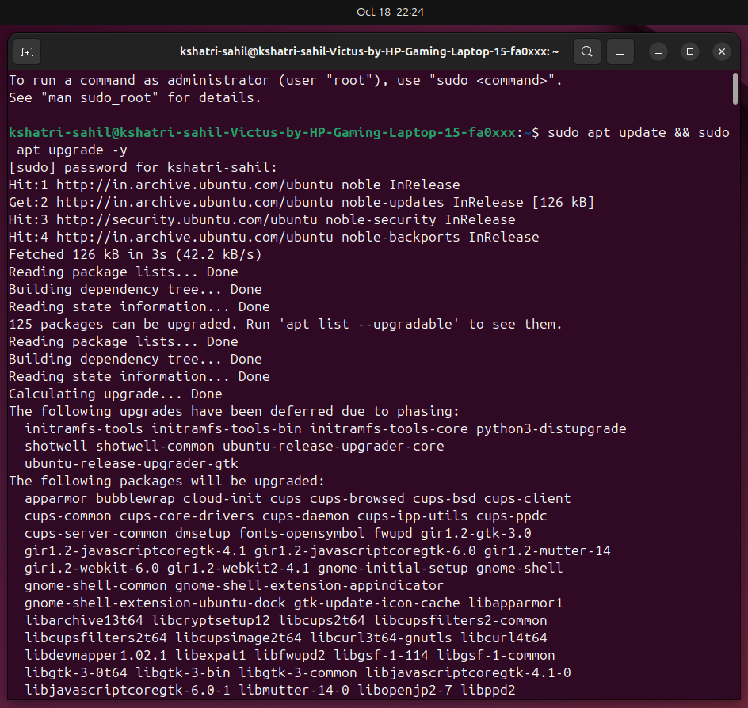

**Step 2: Install Apache, MariaDB, and PHP:**

To run Nextcloud, we need a web server (Apache), a database (MariaDB), and PHP for scripting.

These commands install Apache, MariaDB, and all the required PHP extensions:

> sudo apt install apache2 mariadb-server libapache2-mod-php7.4

>sudo apt install php7.4 php7.4-mysql php7.4-xml php7.4-curl php7.4-gd php7.4-zip php7.4-mbstring php7.4-intl php7.4-json

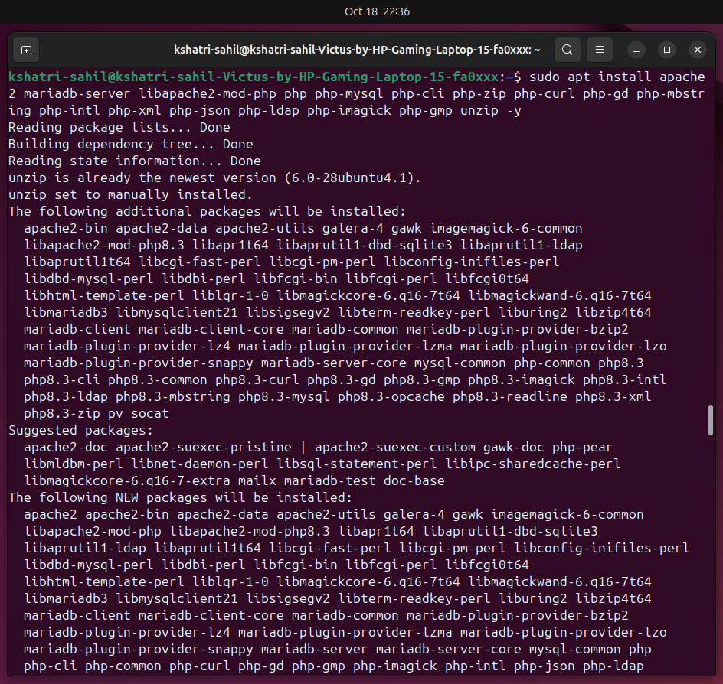>sudo systemctl status apeche2

**Step 3: Set Up MariaDB for Nextcloud:**

Run the secure installation to set up root passwords and secure the database:

>sudo mysql_secure_installation

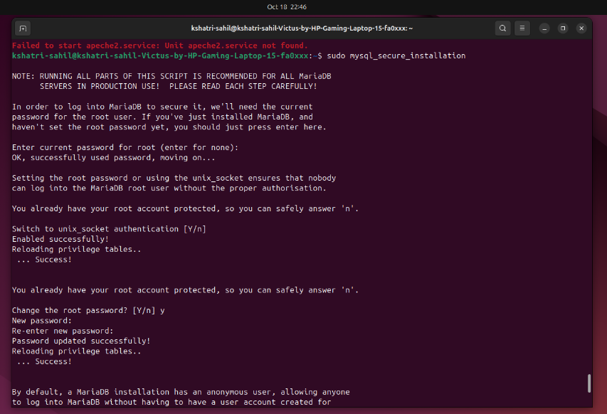

Log into MariaDB as root and Create a database and a user in MariaDB for Nextcloud.:

>sudo mysql -u root -p

CREATE DATABASE nextcloud;

CREATE USER 'nextclouduser'@'localhost' IDENTIFIED BY 'your_password';

GRANT ALL ON nextcloud.* TO 'nextclouduser'@'localhost';

FLUSH PRIVILEGES;

EXIT;

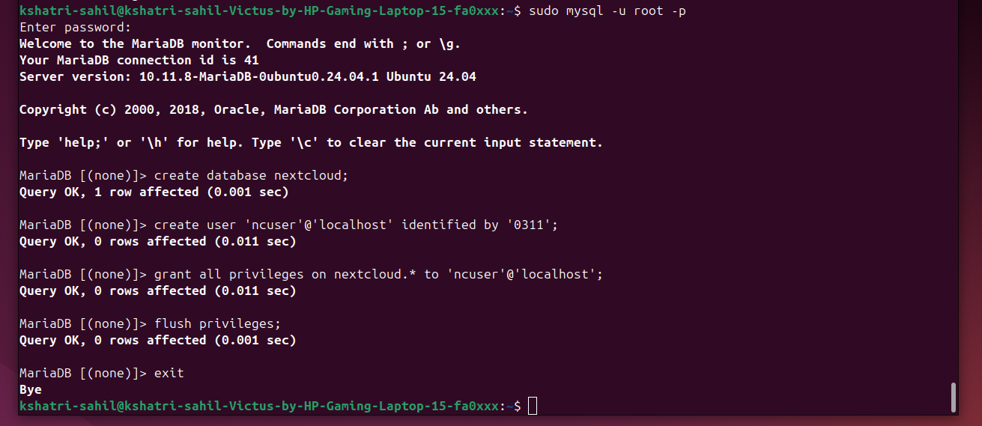

**This sets up a secure MariaDB installation, creates a database called nextcloud, and a user with the necessary permissions.**

**Step 4: Download and Install Nextcloud:**

Now, Download Nextcloud and set up permissions.

This command downloads and unzips the Nextcloud files to the /var/www/nextcloud directory and sets the appropriate permissions.

>wget https://download.nextcloud.com/server/releases/nextcloud-25.0.0.zip

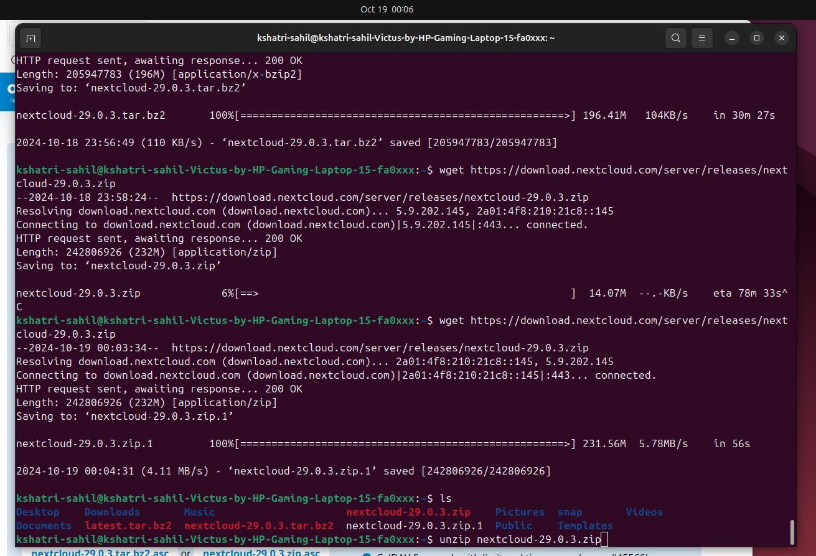>sudo unzip nextcloud-25.0.0.zip -d /var/www/

>sudo chown -R www-data:www-data /var/www/nextcloud

>sudo chmod -R 755 /var/www/nextcloud

Enable the site and necessary Apache modules:

>sudo a2ensite nextcloud.conf

>sudo a2enmod rewrite headers env dir mime

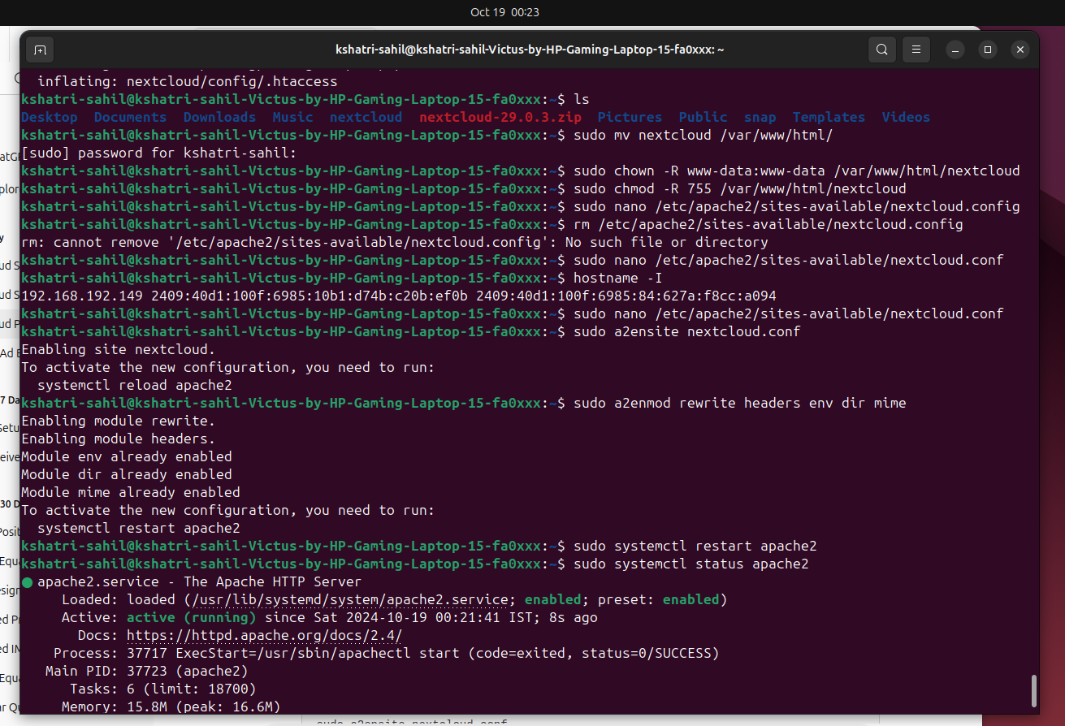>sudo systemctl restart apache2

**Step 5: Configure Apache for Nextcloud**

You need to configure Apache to handle both IPv4 and IPv6 connections and add the correct ServerName. Follow these steps

Create a new Apache configuration file for Nextcloud:

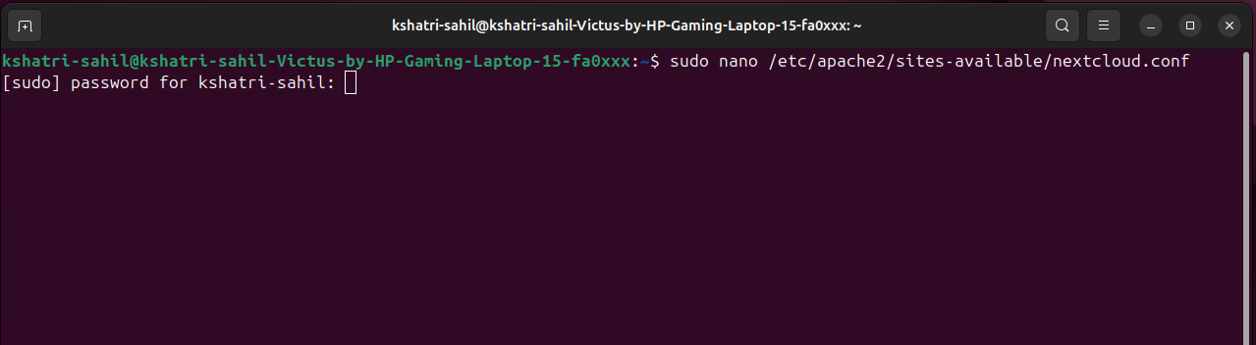>sudo nano /etc/apache2/sites-available/nextcloud.conf

*Add the following to the file:*

<VirtualHost *:80>

DocumentRoot /var/www/nextcloud/

ServerName 198.168.192.149

<Directory /var/www/nextcloud/>

Require all granted

AllowOverride All

Options FollowSymLinks MultiViews

</Directory>

ErrorLog ${APACHE_LOG_DIR}/nextcloud_error.log

CustomLog ${APACHE_LOG_DIR}/nextcloud_access.log combined

</VirtualHost>

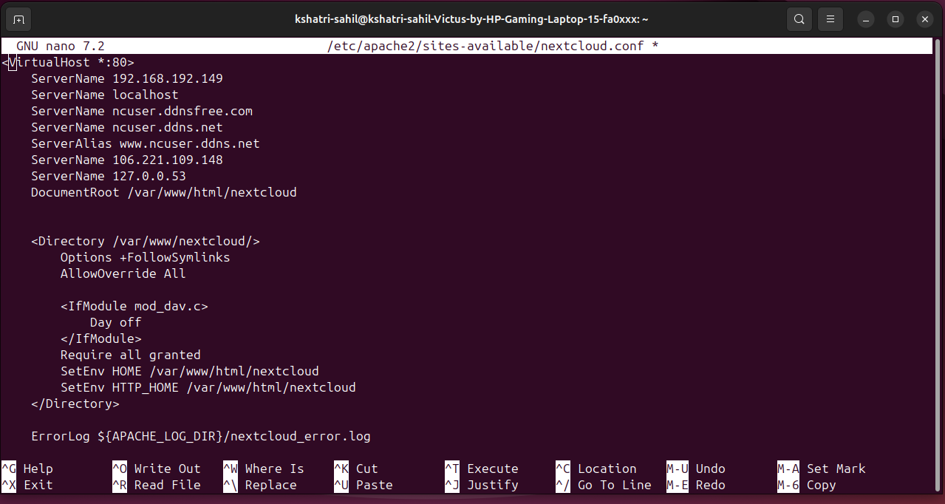

**Step 6: Complete Nextcloud Web Setup**

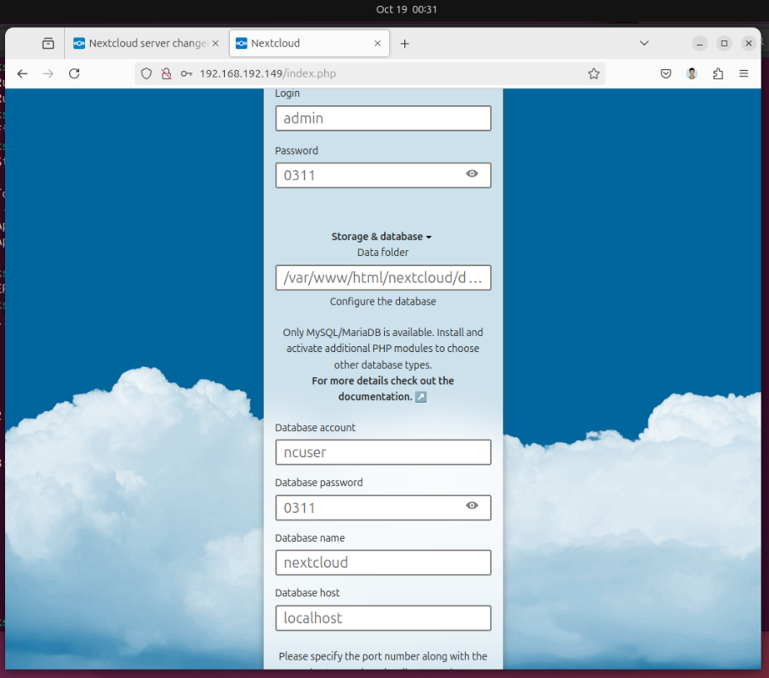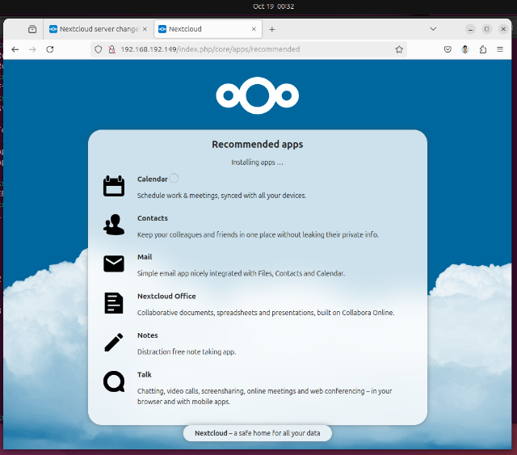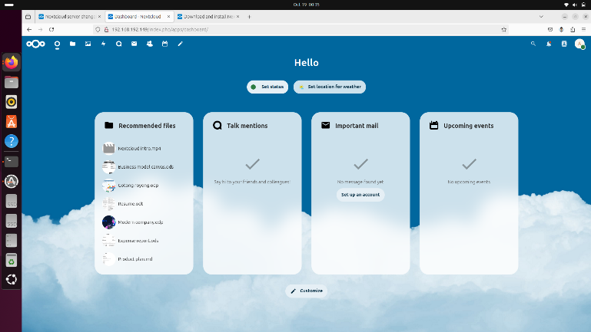Now, open your web browser and go to http://192.168.192.149 to complete the setup by entering your database credentials and creating an admin account.

**Step 7: Install and Configure Ngrok**

Install Ngrok to expose your Nextcloud instance to the internet.

Install Ngrok:

>sudo snap install ngrok

Add your Ngrok authentication token:

>ngrok config add-authtoken 2nf5HUrxcY4wuzK3i6QU48qkIGJ_7Nz6YdSU4biDkss3F2x5b

Start Ngrok for HTTP traffic [This will give you a public URL that forwards to your local Nextcloud instance.]:

>ngrok http 80

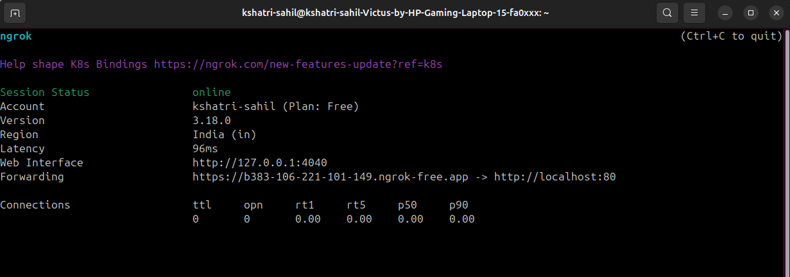

Add the forwarding ip address in /var/www/html/nextcloud/config.config.php:

Open the file;

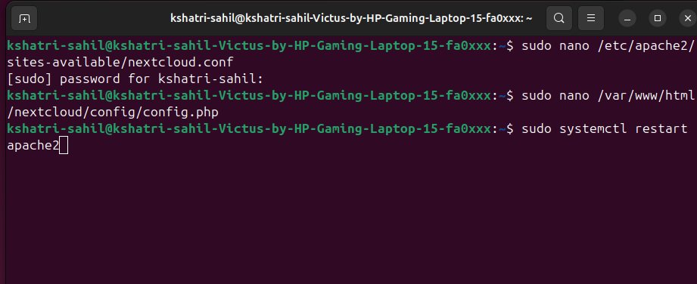>sudo nano /var/www/html/nextcloud/config.config

Add the forwarding ip in trusted domains array:

‘trusted_domain’ =>

Array(

0 => ‘192.168.192.149’, //localhost ip address

1=> ‘https://b383-106-221-101-149.ngrok-free.app’,

),

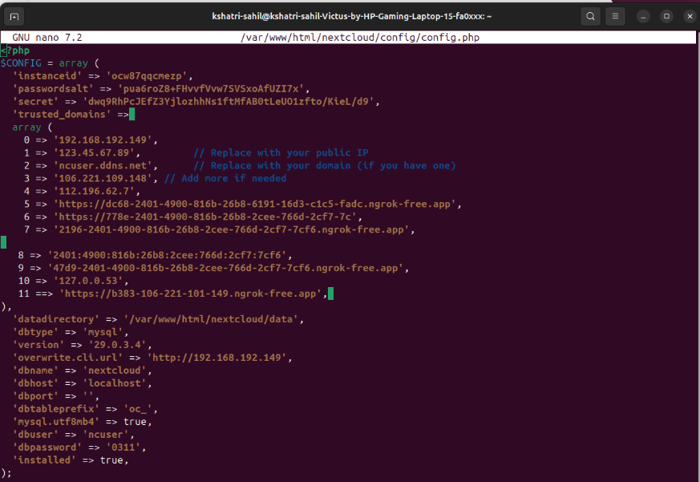

**Step 8: Automate Ngrok on Startup Using crontab**

Install Crontab:

>sudo apt install cron

>sudo systemctl enable cron

>sudo systemctl start cron

This ensures that the cron service is installed and running.

**Set up Ngrok to start automatically:**

Open the crontab editor:

> sudo crontab -e



*Add the following line to the end of the file:*

@reboot /usr/bin/ngrok http 80

**Step 9: Access Nextcloud Web Interface via Ngrok**

After starting Ngrok, it will provide you with a public URL (https://b383-106-221-101-149.ngrok-free.app). Use this URL to access your Nextcloud instance from any device, anywhere.

**Step 10: Managing Nextcloud and Ngrok**

To monitor or manage your Nextcloud instance:

* Restart Apache: >sudo systemctl restart apache2
* Check Ngrok status: >ps aux | grep ngrok

**Step 11: Nextcloud login and Setup**

**After logging in as admin:**

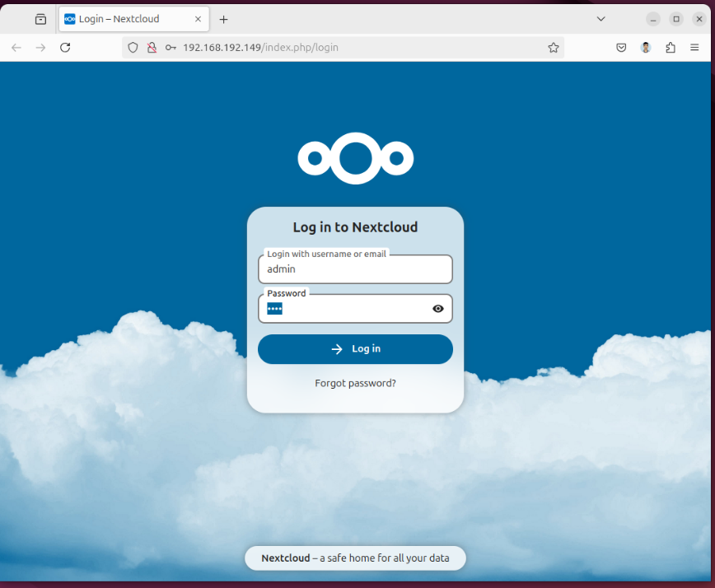

**Adding Files into cloud:**

1. Navigate to “All files”.
2. **A screenshot of a computer

   Description automatically generated**Click on “+New”.

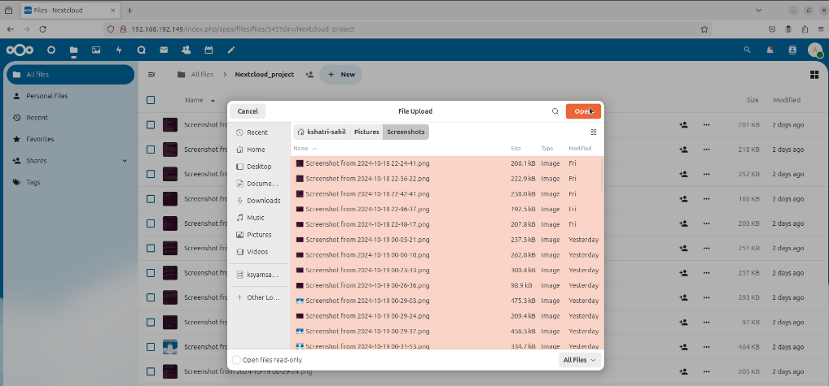

***Select the files which you want to upload***

***As we can see the files are uploaded a few seconds ago***

**Step 12: Adding New user**

* We can add a new user so that they can also use the server to upload their own data.
* The New user cannot see or access other account. Not even the admin can.
* Click on “New Account”
* Fill the required details.
* 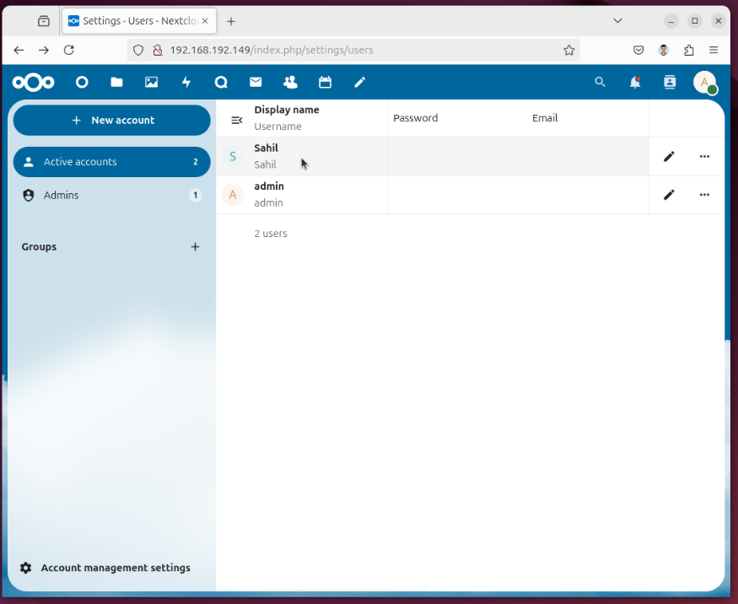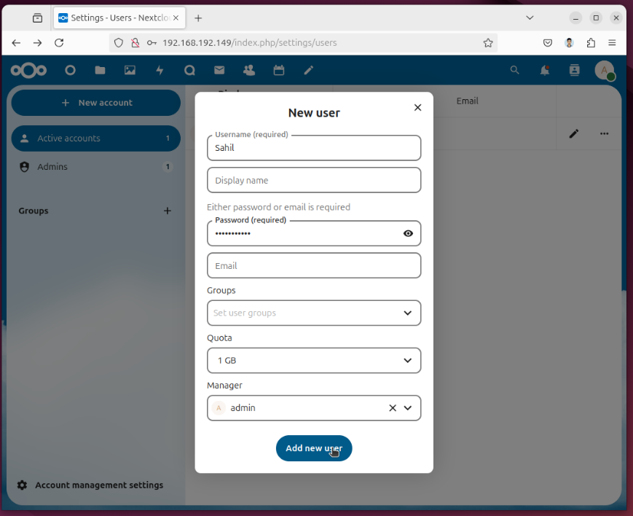Click on “Add new user”.

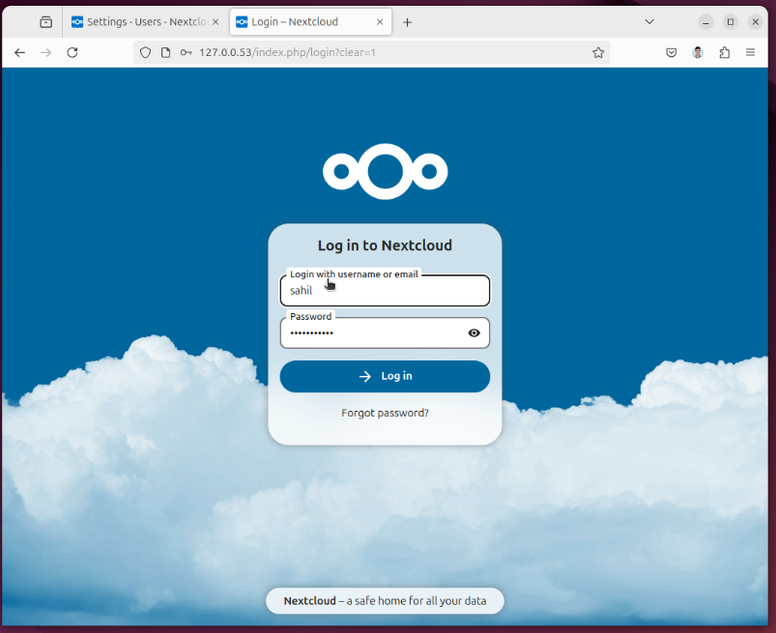**Now** **you can login through the user account (eg: sahil)**

**Step 13: Setting up Nextcloud through mobile app.**

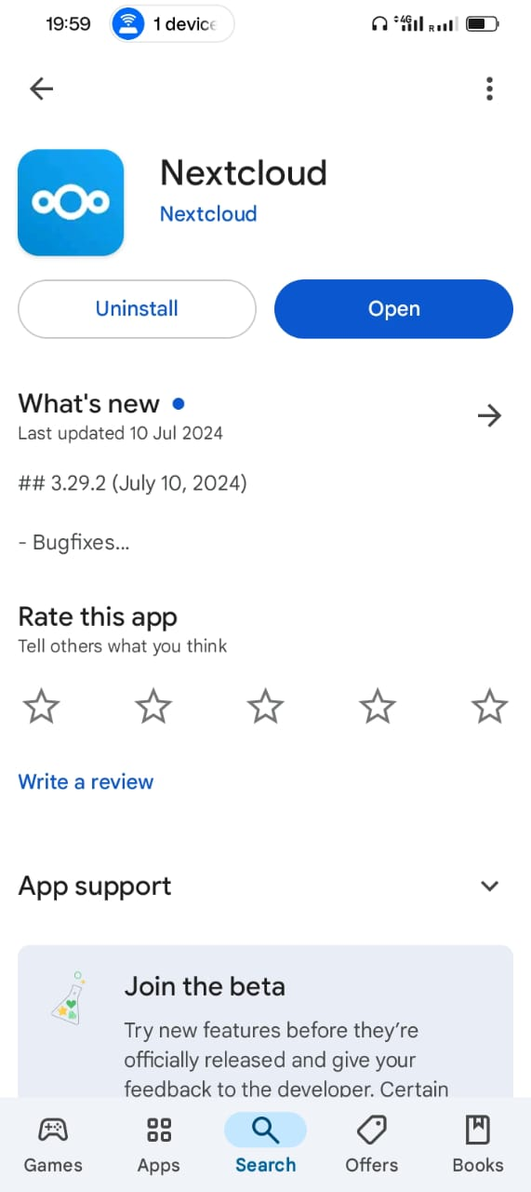

**Enter the Ip address**

**Install the Nextcloud app**

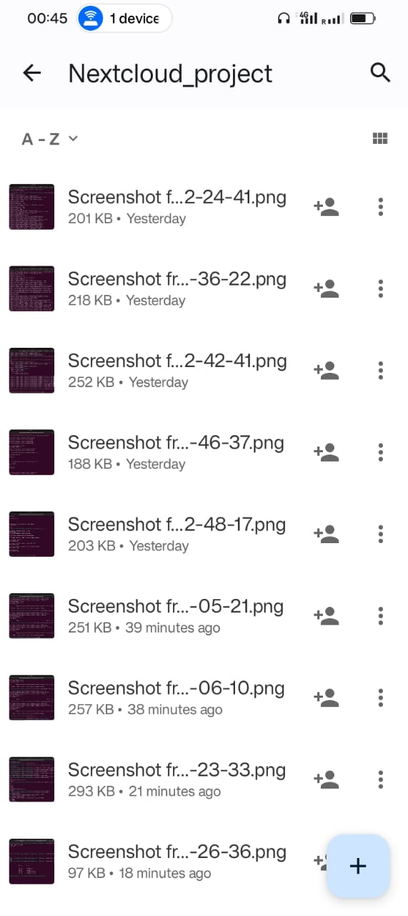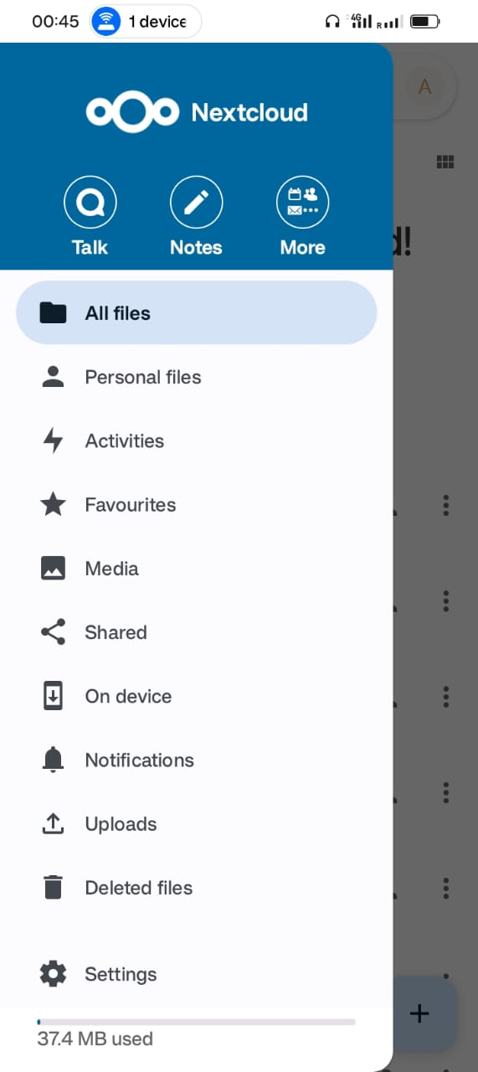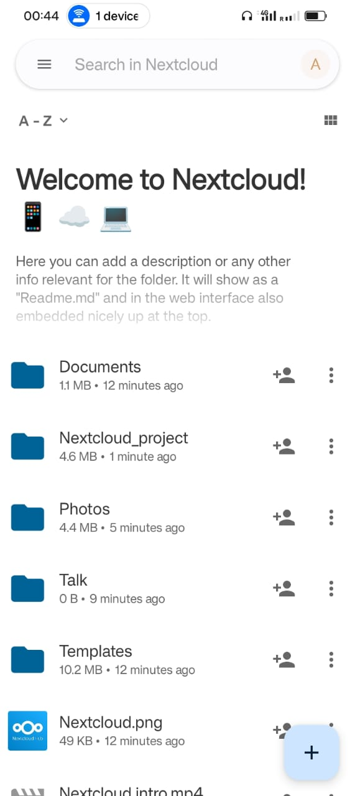Accessing the account through mobile app.

**FUTURE SCOPE**

1. **Enhanced Security Features**:

* **SSL/TLS Configuration**: Implement SSL certificates using Let's Encrypt for secure HTTPS access to the server, improving data security during transmission.
* **Two-Factor Authentication (2FA)**: Integrate 2FA to provide an additional layer of security for user accounts.
* **Regular Security Audits**: Establish a routine for security audits to identify and mitigate vulnerabilities.

1. **Domain Management**

* **Custom Domain Setup:** Transition from using Ngrok to a custom domain name for easier access. This will improve user experience and trustworthiness.
* **Dynamic DNS (DDNS):** If you have a dynamic IP address, consider implementing a DDNS service. This allows your domain to always point to your server, even if the IP changes.

**3. Scalability and Performance Optimization**

* **Load Balancing**: As user demand increases, implement load balancing to distribute traffic across multiple servers. This will enhance performance and reliability.
* **Database Optimization**: Regularly optimize the MariaDB database for faster access and efficiency. Consider using caching mechanisms like Redis or Memcached.
* **Content Delivery Network (CDN)**: Utilize a CDN to cache static content closer to users, improving load times and reducing server load.

**CONCLUSION**

In conclusion, setting up a Nextcloud server provides a robust and secure solution for managing personal data and collaborating with others across various devices. By enabling users to host their own cloud services, Nextcloud empowers individuals and organizations to maintain control over their files, calendars, and contacts, fostering a greater sense of privacy. With features like file sharing, collaborative editing, and integrated communication tools, Nextcloud enhances productivity and teamwork in a user-friendly environment.

The incorporation of security measures, such as HTTPS configuration and the ability to set up user permissions, ensures that sensitive data remains protected against unauthorized access. Moreover, the integration of dynamic DNS services and tools like Ngrok allows users to access their Nextcloud instance from anywhere, bridging the gap between local servers and global connectivity.

Nextcloud's adaptability to custom domains enables a professional appearance and easy access for users, contributing to a seamless experience. With its open-source nature, Nextcloud supports a vibrant community that continuously improves the platform, introducing new features and enhancements tailored to user needs.

As data privacy concerns grow, Nextcloud stands out as a versatile and trustworthy cloud solution, allowing users to scale their storage capabilities while maintaining performance and security. By prioritizing user control, collaboration, and data protection, Nextcloud remains an ideal choice for those seeking a comprehensive self-hosted cloud environment that aligns with modern data management needs.

**REFERENCES**

Github link: https://github.com/Kshatri-Sahil/Personal_Cloud_Server_with_Nextcloud